**HARSH RATHOD**

[**harshrathod6874@gmail.com**](mailto:harshrathod6874@gmail.com)

**04/02/2020**

**MINOR PROJECT**

**CS12B1**

**OVERVIEW**

Modern websites use databases to store and manage information. We want to better understand the

framework that makes the connection between a webpage and a database possible. And will try to exploit

the known vulnerability to get access into database and find out more information.

**OBJECTIVE**

To learn about SQL injection and exploit the vulnerability.

To explore web-application security.

We were provided with a URL: <http://35.225.74.121:1337/index.php>

Our aim is to:

* Find out the vulnerability
* exploit the vulnerability
* grab the ‘flag’.
* Suggest a patch for this bug.

The tool that we used to explore the vulnerability in the given website is “sqlmap”.

Introduction:

sqlmap is an open source penetration testing tool that automates the process of detecting and exploiting SQL injection flaws and taking over of database servers. It comes with a powerful detection engine, many niche features for the ultimate penetration tester and a broad range of switches lasting from database fingerprinting, over data fetching from the database, to accessing the underlying file system and executing commands on the operating system via out-of-band connections.

<http://sqlmap.org/>

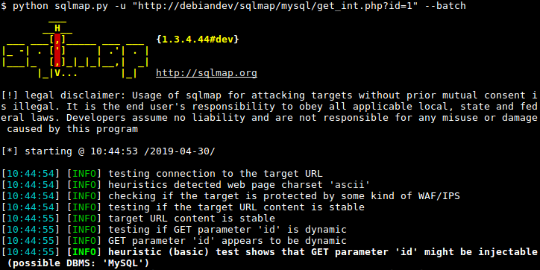

Commands and procedure:

* sqlmap -u <http://35.225.74.121:1337/index.php> --forms –crawl=2 --tables

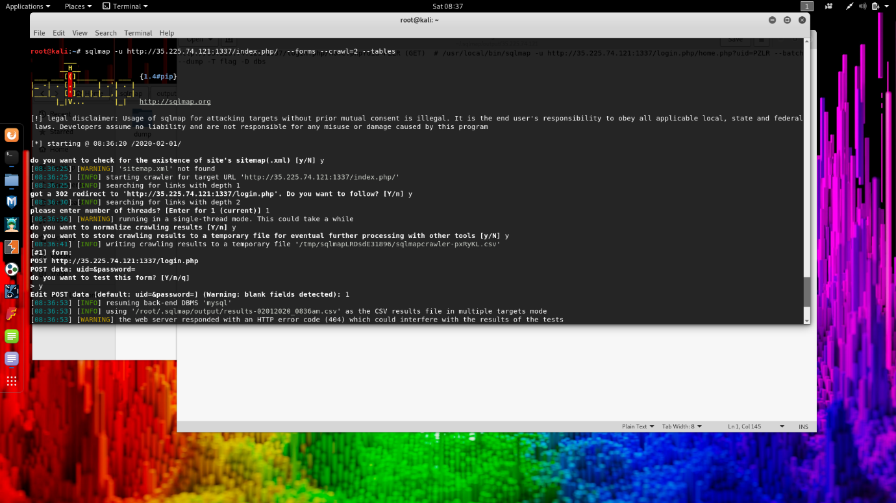

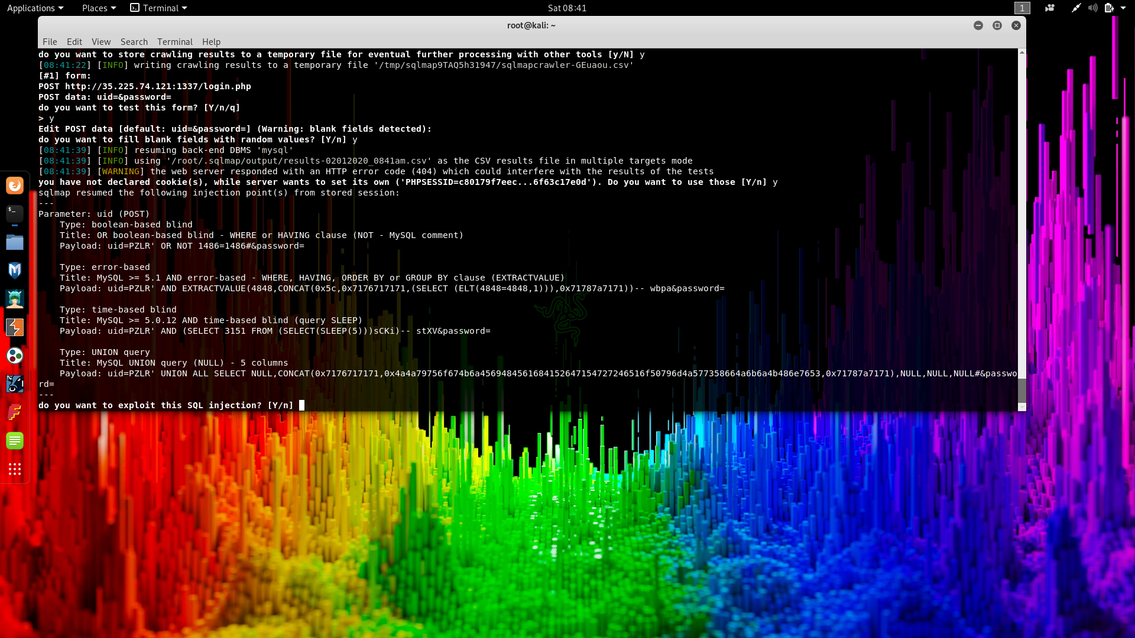

The above command when executed gives us the payloads which cane be used to exploit the database.

We also got a vulnerable parameter uid, which can be injected with a bad query with uid=PZLR

In our next command we will use this parameter to enhance our results

* sqlmap -u <http://35.225.74.121:1337/index.php?uid=PZLR> –forms

--crawl=2 --risk=2 –level=2 –tables

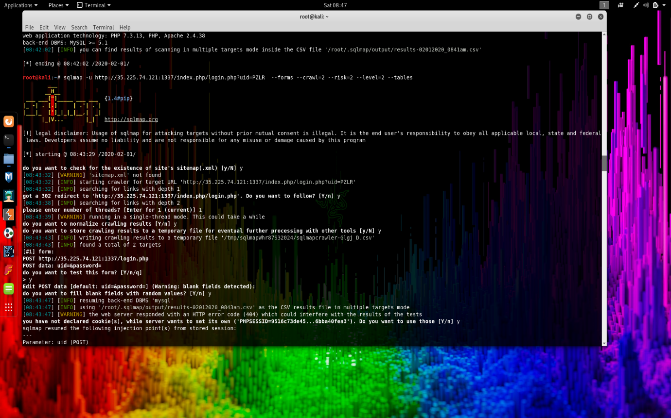

We have also introduced two more parameters i.e., risk and level.

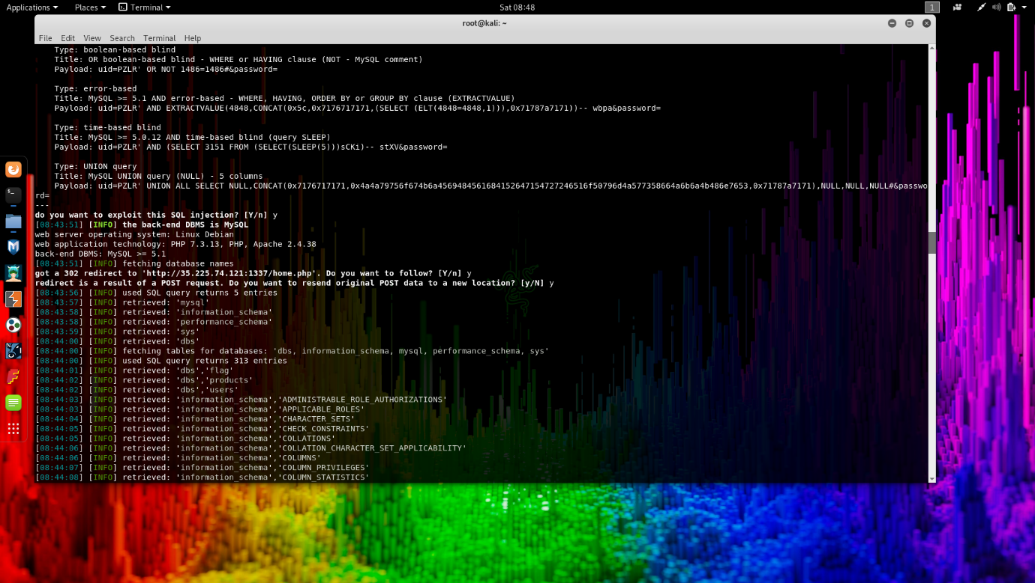

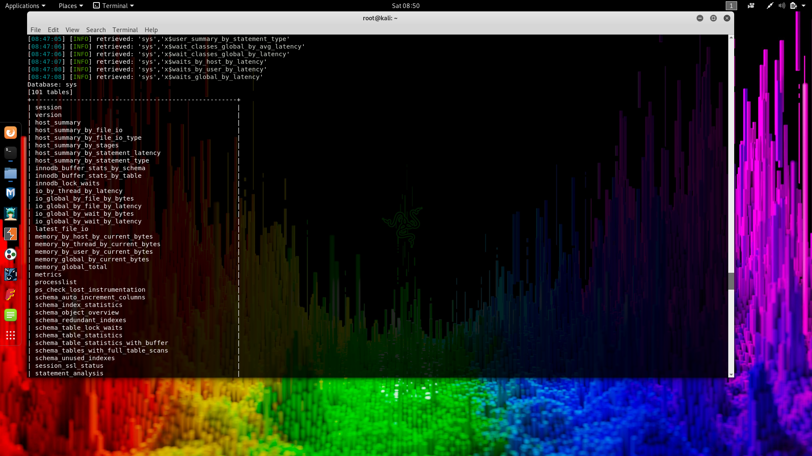

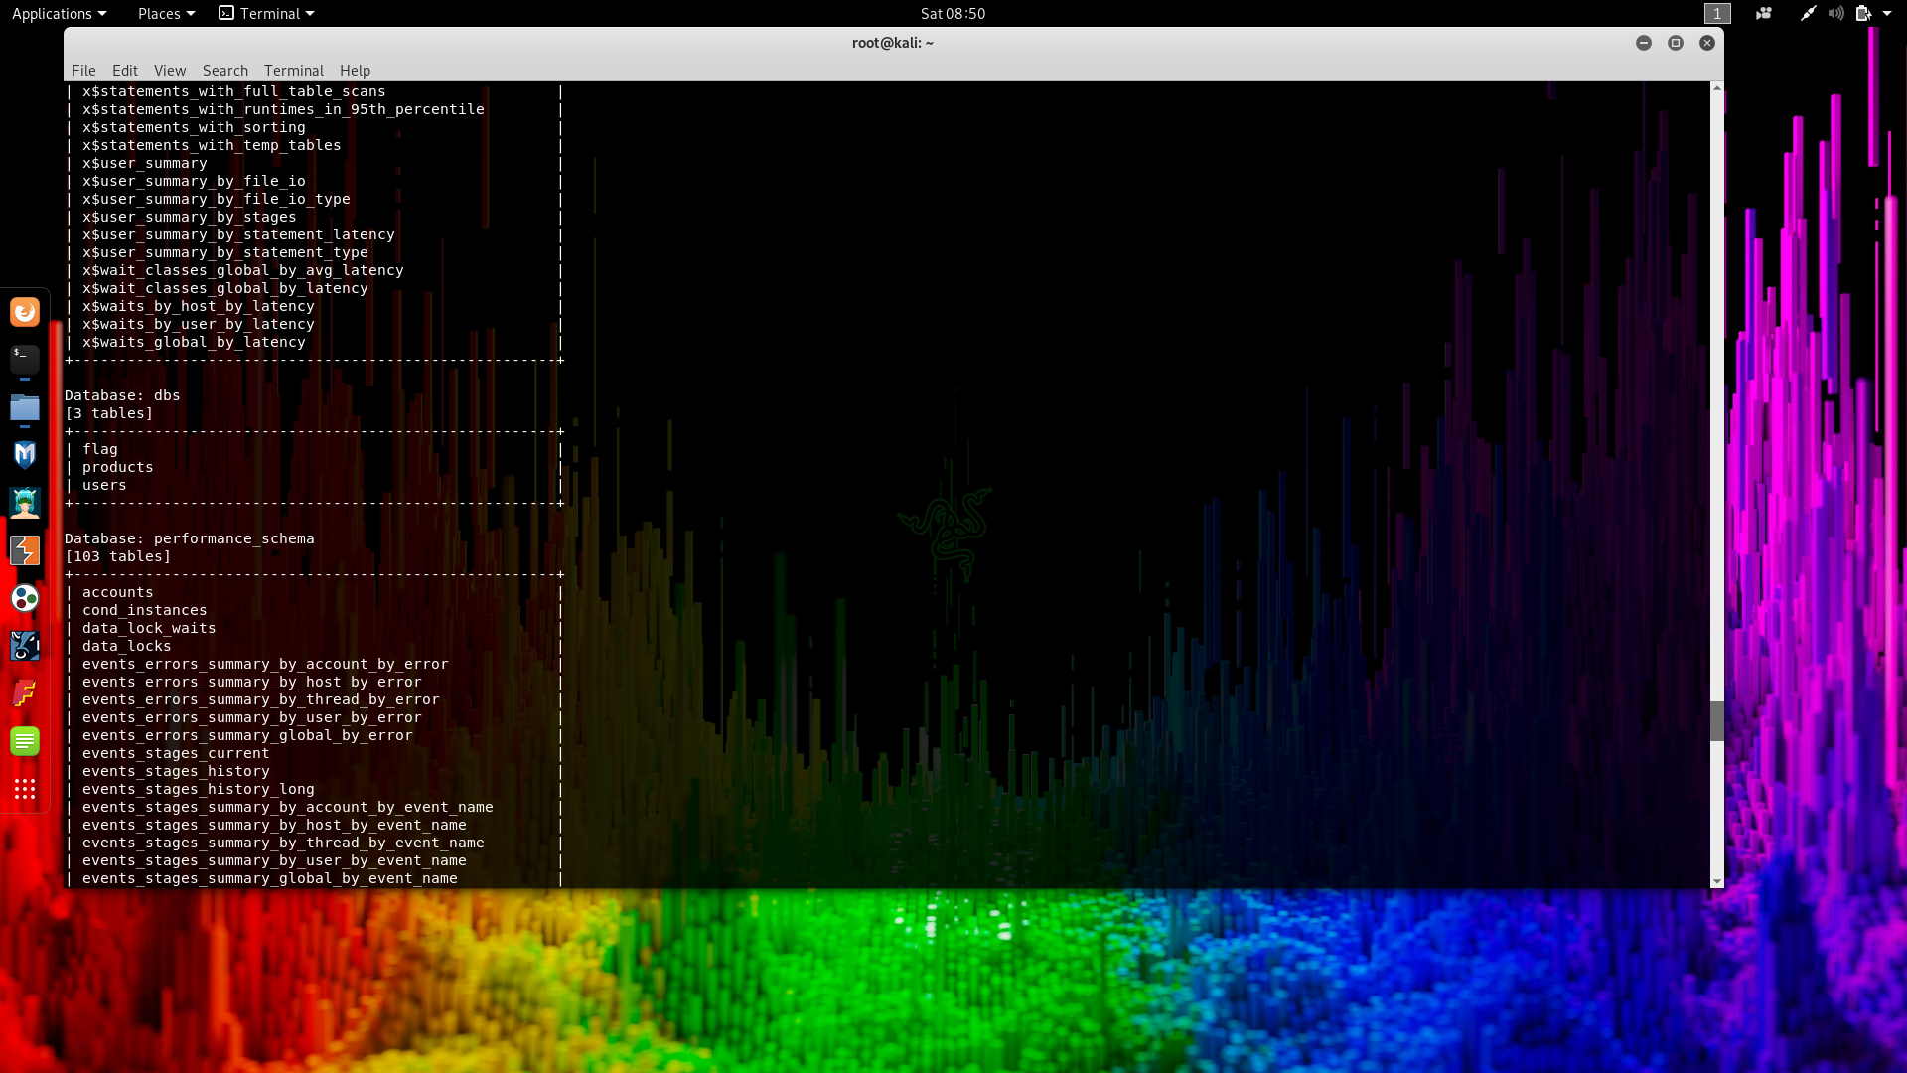

As we can see we got a table named flag, now we just have to dump the table with the command –dump.

* sqlmap -u <http://35.225.74.121:1337/index.php?uid=PZLR> –forms

--crawl=2 --risk=2 –level=2 –tables -T flag --dump

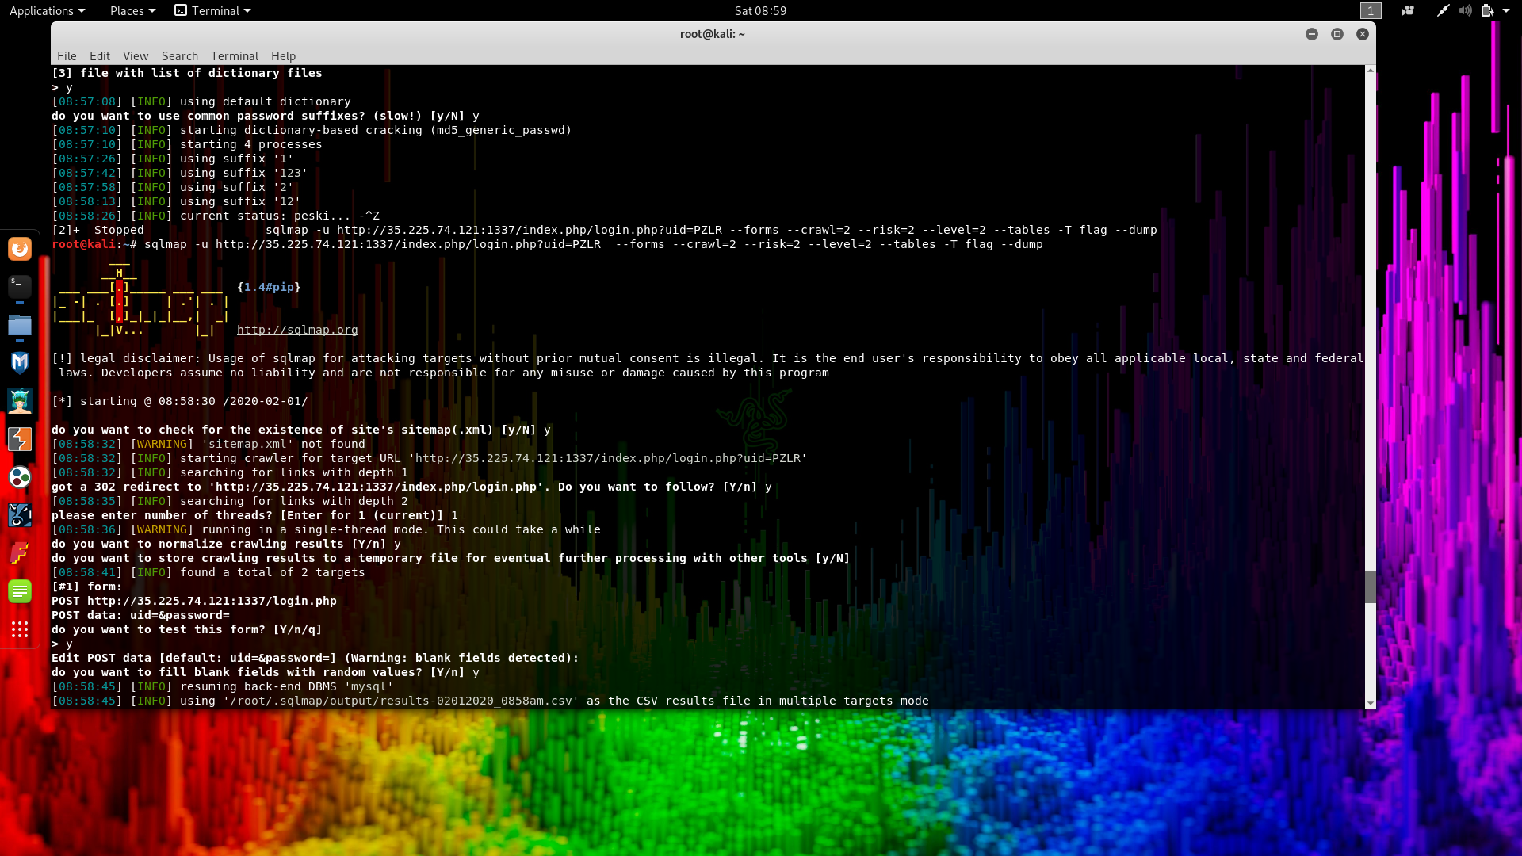

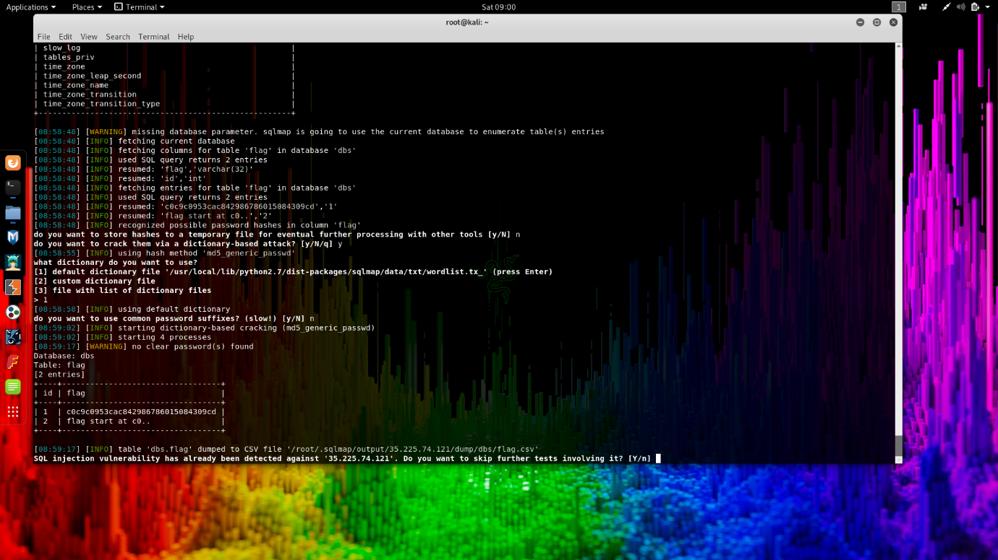

As we can observe from the above picture that we have got the value of the flag.

**Parameter tampering** focuses on a vulnerability in the way an application handles untrusted data. This can be from things like failure to check data integrity, malicious intent, [SQL injection](https://lonewolfonline.net/sql-injection-attacks/), cross site scripting or even binaries containing malware.

Parameter tampering is merely changing the value of a GET or POST variable in the URL address bar by means other than normal application usage. The untrusted data can also can also come from the request headers or from cookies, so there are a number of attack vectors which must be addressed.

Suggestions:

* **You must assume that all aspects of HTTP request can and will be manipulated by attackers.**
* The verb, path, protocol, accept headers, user agent strings, referrers, accept language, cookies and the request body are all untrusted data.
* Don't rely on controls which depend on the browser - don't depend on client-side validation.
* Be conscious of where risks might be present in automated processes such as model binding and mass assignment attacks.
* Consider which verbs should be allowed for a resource and block the others.
* Fuzz test any and all properties where an attacker may attempt to gain access.
* Least privilege is the concept and practice of restricting access rights for users, accounts, and computing processes to only those resources absolutely required to perform routine, legitimate activities.
* **Escape** when you're outputting that saved data to the frontend. Do this once and only once, at the moment of output. Don't return complex HTML fragments in functions, echo them, and escape when you echo. Escaping might mangle your output if unsafe stuff makes it through, but it guarantees that the URL is always a URL, even if it's a broken URL, that the text is always text, even if it contained a dangerous tag, etc